**Week 5 - Bringing the project together**

Published by Thomas on March 7 2021

This week, we worked to improve our design and prototype in response to the ¼ feedback from last week. Following feedback from the faculty, we focused on improving our presentation of the story, which was poorly defined as of yet. We fleshed out our story outline and created sample dialogue for one scene in our game. The story will be a crucial vehicle to deliver the tutorial and educational content, so it’s important to communicate how that will work. In our client meeting, we got feedback on our sample dialogue, and then we got additional feedback from the client on the story outline through email and google drive collaboration.

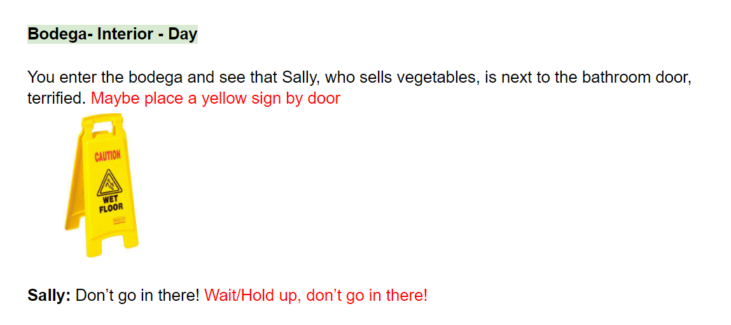

From the engineering standpoint, we made a lot of progress integrating our various systems. We implemented the credit card mechanic, allowing the player to place any purchases onto their credit card. We also created a dialogue system which will allow our designers to input entire scenes entirely from the inspector. We implemented an upgrade system, which will allow the player to spend their money, improve the bodega and get a feeling of reward from gameplay.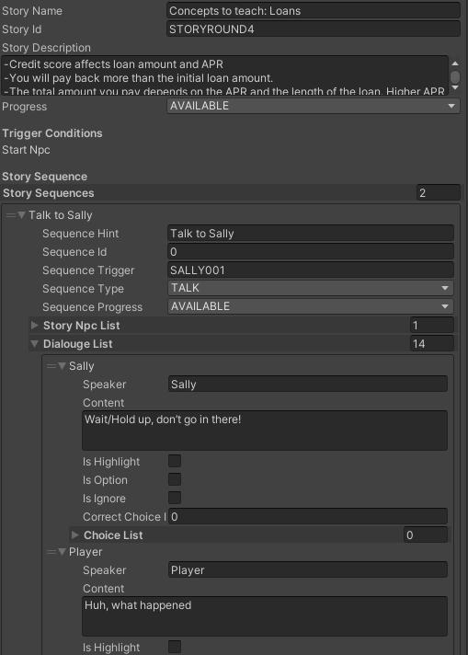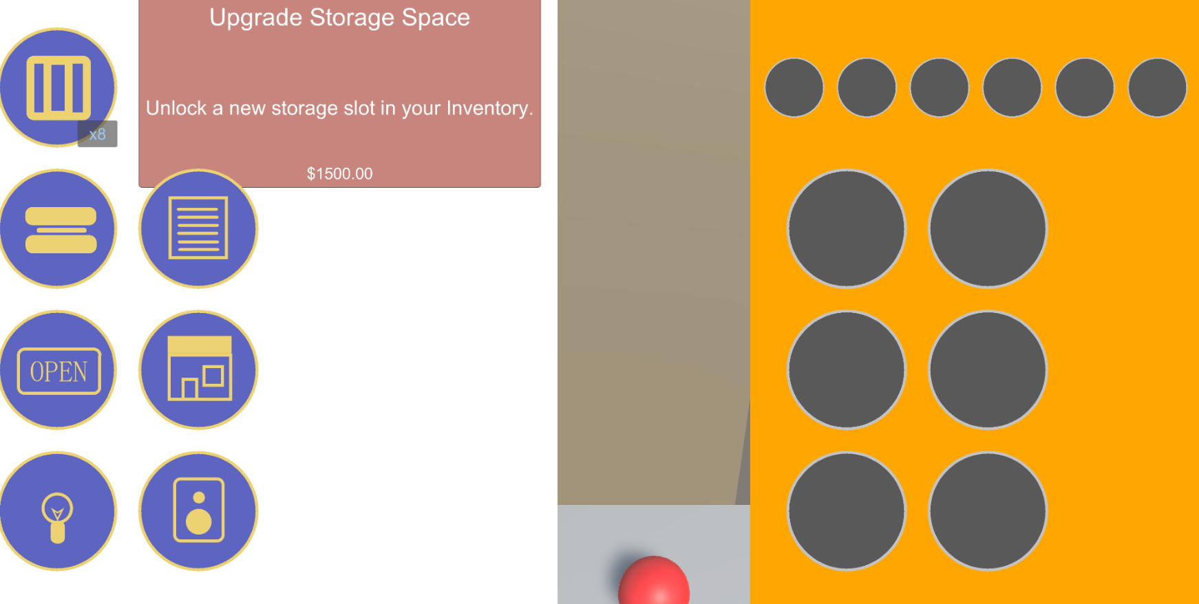

For next week, we plan to bring all the planned features into the main game, including credit score, loans and stocks. We will then focus on creating a high-quality version of the inventory gameplay (the basic gameplay loop) that we are able to playtest among ETC students and faculty before our ½ presentation.